W-16

**YEAR 12 PHYSICS**

**ASSIGNMENT 1 - MOTION**

**Name:** **Mark:** 

1.

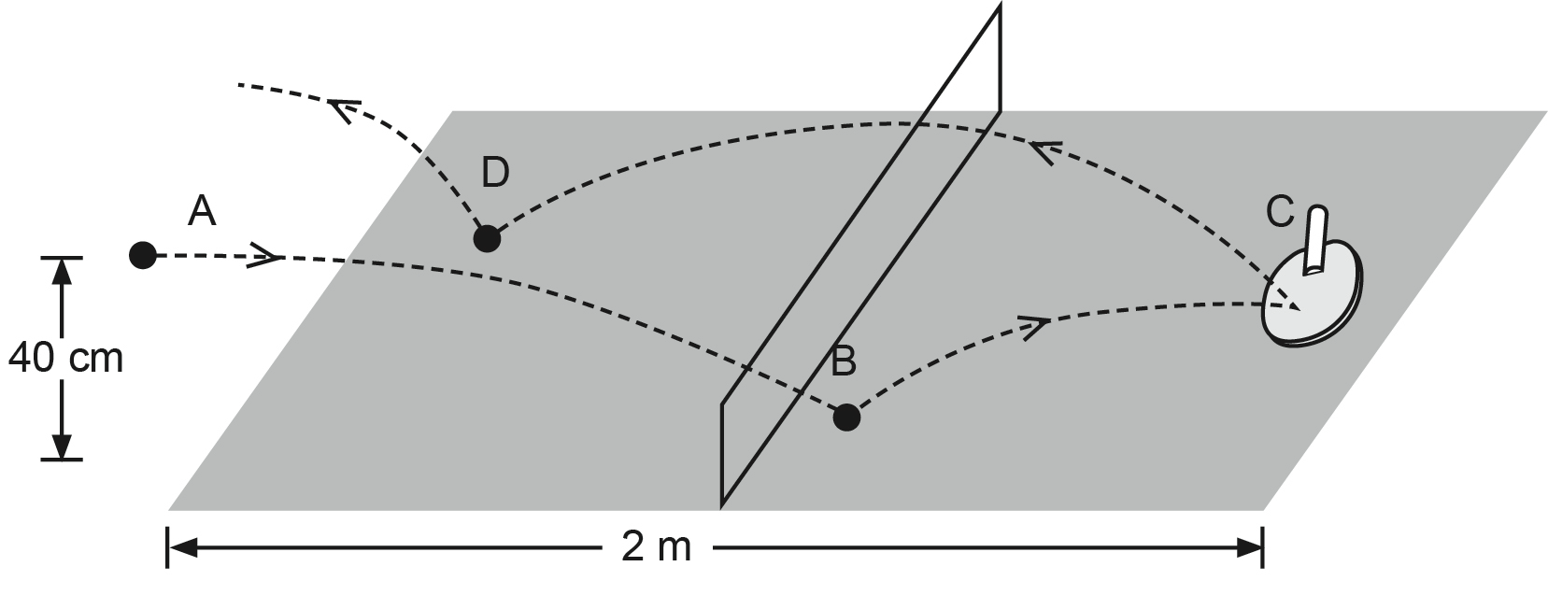

Two students are playing a game of ping-pong (table tennis). The ball is served and begins its its path from point ‘A’, which is 40 cm above the level of the table. The trajectory then taken by path from Point ‘A’, which is 40 cm above the level of the table. The trajectory then taken by the the ball is also shown on the diagram above.

Each player hits the ball and gives it the same speed. Ignore any effect of friction or resistance between the table and the ball and air when answering the questions below.

(a) Consider the instantaneous motion of the ball **at the moment** that it has maximum

contact with the table at Point ‘B’. By circling the appropriate arrows, indicate the direction of its (3 marks)

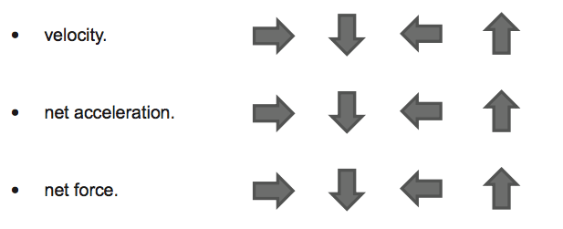

(b) At which point (‘A’ or ‘C’) does the ball experience the greater acceleration? Justify your answer. (3 marks)

2. A ball of mass 1.50 × 10-2 kg rolls along a rail that includes a vertical loop of radius

*R* = 0.500 m as shown. There is negligible friction.

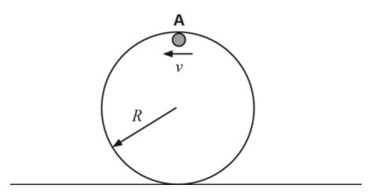

At Point A the ball is **just** in contact with the rail. Draw a free body diagram of the ball when it is at Point A, and calculate the minimum velocity, *v*, required to keep it in contact with the rail at this point. Show **all** workings. (5 marks)

Free body diagram:

Calculation:

3. In order to drop a parcel, an aircraft flying horizontally 150 m above sea level with a speed of 216 kmh-1 approaches from behind a surfaced submarine that is moving in the same direction. The speed of the surfaced submarine is 36.0 kmh-1 and its deck is just at sea level. Ignore air resistance.

Calculate the time taken for the parcel to drop from the aircraft onto the surfaced submarine, and hence determine the horizontal distance from the submarine at which the aircraft must be when it releases the parcel. Show **all** workings. (7 marks)

4. An aircraft attempts to land along a north-south aligned landing strip. It approaches from the south and has an air speed of 133 kmh–1. The wind is blowing from the west at 45.0 kmh–1. Draw a vector diagram to show the direction the aircraft needs to head and calculate its actual velocity, in ms–1, relative to the runway. Show **all** workings. (5 marks)

5. During a chase scene in a movie, an actor drops onto the top of an elevator that is descending at a constant speed of 1.00 ms-1. The time taken to land on top of the elevator is 6.10 × 10-1 s. Determine the distance in metres the elevator is below the actor when she starts her drop. Show **all** workings. (4 marks)

6. A car is driving over a hill with a radius of 250 m at a speed of 30.0 ms-1. Determine the magnitude of the net force experienced between a 65.0 kg passenger and their seat or seat belt. (3 marks)

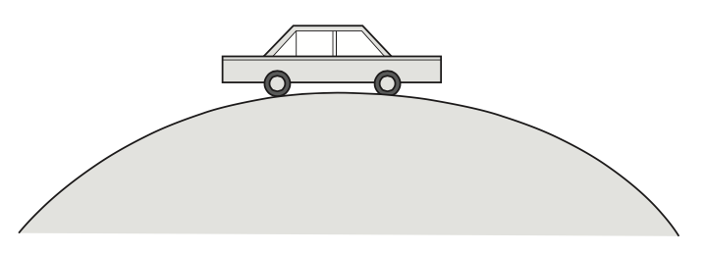

7. Shown are a photograph and diagram of a child’s swing suspended 7.00 metres below the branch of a large tree. The wooden seat has a mass of 1.00 kg and is supported by ropes as shown in the diagram below. When the seat is horizontal, the ropes that **attach to the seat** each make an angle of 15.0° to the vertical.

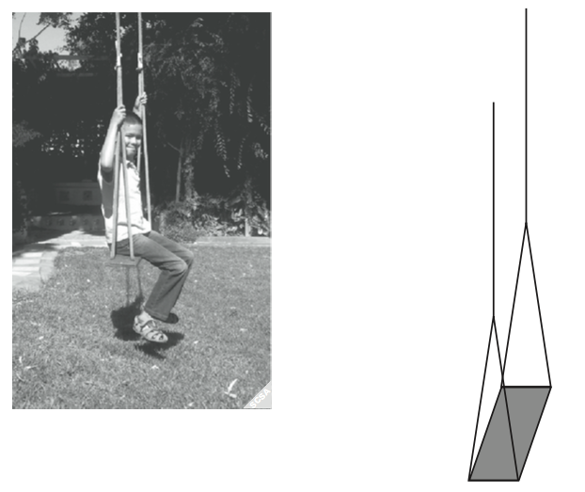

Calculate the maximum tension in each of the angled sections of the rope that attach to the seat when a 27.0 kg boy is sitting on the swing and moving with a tangential velocity of 4.00 ms-1. Show **all** workings. (6 marks)

8. The diagram below shows the forces acting on a car following a curve on a banked track. The car is travelling at 17.0 ms-1 without slipping. Calculate the radius of the track.

(5 marks)

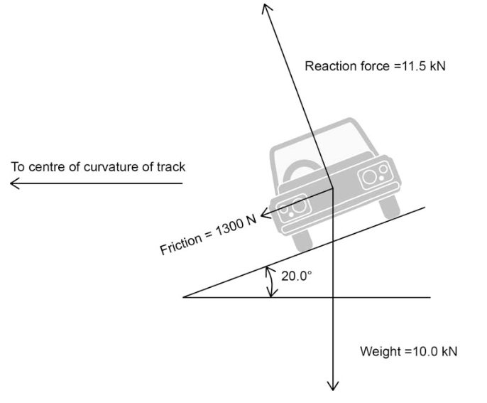

9. Your use of appropriate significant figures will be assessed in this question.

The photograph shows a swimming pool toy that sprays water when the plunger is pressed into the barrel containing water. A boy, using the toy, sprays water vertically from a height of 1 m and counts the time from the last drop of water leaving the barrel to it hitting the ground and finds it to be 3 s.

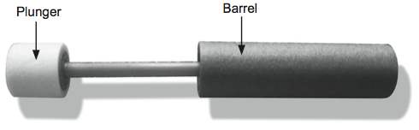

Estimate the angle at which the toy should be held if it is to be used to spray water from the surface of a swimming pool onto a person 4 m away. Assume that air resistance is negligible and show **all** your workings.

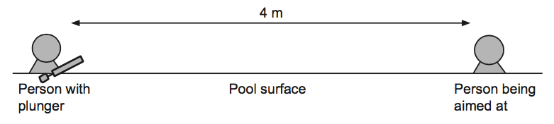

Hint: You may need to use the trigonometric identity sin 2θ = 2 sinθ cosθ to answer this question. (6 marks)

10. An aircraft is flying horizontally with a constant speed of 600 kmh-1 at an altitude of 5000 m. The upward (lift) force provided by the wings that is necessary to keep the aircraft in level flight is 9.80 × 104 N.

(a) Show that the mass of the aircraft must be 1.00 × 104 kg. (3 marks)

(b) The pilot begins a turn by tilting the aircraft so that its wings are at 15.0° to the horizontal as shown. Assume that the airspeed does not change, and that the size and angle to the wing of the lift force remain constant.

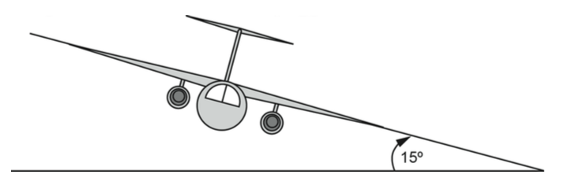

Draw a free body diagram below labelling the forces acting on the aircraft. Ignore drag/friction and thrust forces directed into and out of the page. (2 marks)

(c) Calculate the horizontal radius of the aircraft’s turn, assuming the airspeed does not change. (5 marks)

(d) Describe any effects that this turn will have on the altitude of the aircraft. No calculations are required. (2 marks)

11. Andrew and Sarah were at the park and noticed a tyre-swing hanging in a tree. They realised that it would behave as a pendulum and would complete one swing (return to its starting point for one complete cycle) with a period (T) in seconds. They had previously discussed pendulums in class and been given the equation:

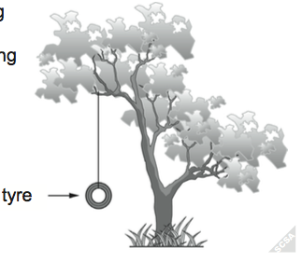

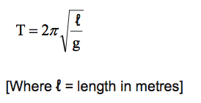

(a)   The tyre swung with a period of 3.84 s. Determine the length of the rope in metres.  (2 marks)

(b)   Andrew and Sarah decided to conduct an investigation to determine the relationship between the length of a pendulum and its period.  An incomplete table of results for this investigation is shown below:

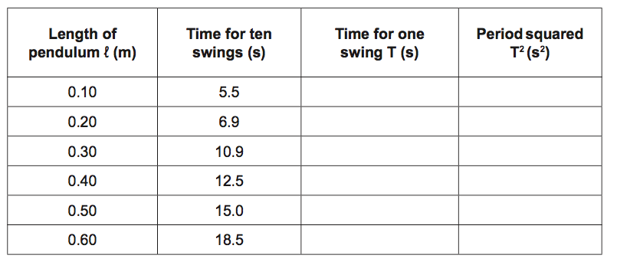

(i)   Complete the above table. (2 marks)

(ii)   Use the data from the table to plot a straight line graph on the grid provided to demonstrate the relationship between the length of the pendulum and the square of the period (plot l on the x-axis). (4 marks)

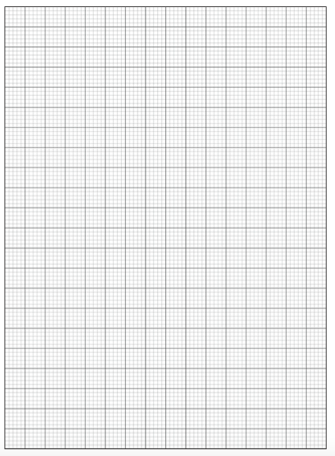

(iii) Use your graph to determine the pendulum length that gives a period of 1.0 s.  (3 marks)

(iv) Determine the gradient of your graph using a line of best fit. (4 marks)

(v) Use your gradient to determine the experimental value of g. (3 marks)